4.2 Linear Approximations & Differentials Worksheet

- Find the linearization of the function at .

If , then , so we have the point: .
The slope of the line is given by . We see that . Therefore, .
So the linearization at is:

We know that for values of x near 1.

- Find the linearization of the function at .

If , then , so we have the point: .
The slope of the line is given by . We see that . Therefore, .
So the linearization at is:

We know that for values of x near 2.

- Use a linearization to approximate the number .

is hard to calculate by hand, but is easy. Let .
We will make a linearization at and then estimate .
If , then , so we have the point: .
The slope of the line is given by . We see that . Therefore, .
So the linearization at is:

We know that for values of x near 4. Therefore,

- Approximate the number .

is hard to calculate by hand, but is easy. Let .
We will make a linearization at and then estimate .
If , then , so we have the point: .
The slope of the line is given by . We see that . Therefore, .
So the linearization at is:

We know that for values of x near 1. Therefore,

- Use the techniques of linear approximation to estimate the following quantities. Write each answer in decimal form. Show all work by hand.
is hard to calculate by hand, but is easy. Let .
We will make a linearization at and then estimate .
If , then , so we have the point: .
The slope of the line is given by . We see that . Therefore, .
So the linearization at is:

We know that for values of x near 1. Therefore,

is hard to calculate by hand, but is easy. Let .
We will make a linearization at and then estimate .
If , then , so we have the point: .
The slope is given by . We see that . Therefore, .
So the linearization at is:
We know that for values of x near 100. Therefore,

is hard to calculate by hand, but is easy. Let .
We will make a linearization at and then estimate .
If , then , so we have the point: .
The slope is given by . We see that . Therefore, .
So the linearization at is:
We know that for values of x near . Therefore,

- Consider the function .

- Approximate and dy as x changes from 1 to 2.

- Sketch a picture of the curve and the values of and dy.

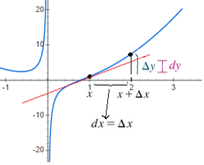

- Consider the function .

- Find general formulas for and dy.

- Approximate and dy when and .

